**Roasted Acorn Squash with Mushroom Ragu**

Serve savory mushroom ragù in acorn squash bowls for a dramatic dish that is surprisingly filling.

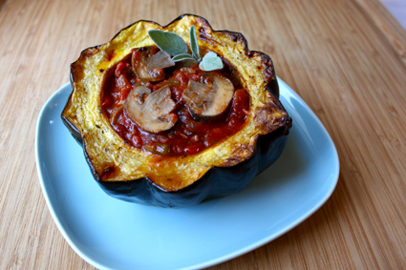

**Total Time:**1 hr. 8 min.  
**Prep Time:**10 min.  
**Cooking Time:** 58 min.  
**Yield:**2 servings

**Ingredients:**  
1 acorn squash, cut in half, seeds removed  
3 tsp. olive oil, divided use  
½ medium onion, chopped  
1 clove garlic, finely chopped  
1 cup sliced mushrooms  
1 (15-oz.) can low-sodium crushed tomatoes  
1 tsp. fresh oregano (or thyme), finely chopped  
Sea salt and ground black pepper (to taste; optional)

**Preparation:**  
1. Preheat oven to 400° F.  
2. Brush the interior of each squash half with ½ tsp. oil.  
3. Bake for 45 to 50 minutes, or until tender when pierced with a fork. Remove from oven. Set aside.  
4. Heat remaining 2 tsp. oil in large saucepan over medium-high heat.  
5. Add onion and mushrooms; cook, stirring frequently, for 6 to 7 minutes, or until onions are translucent and mushrooms are lightly browned.  
6. Add garlic; cook for 1 minute.  
7. Add tomatoes and oregano. Season with salt and pepper if desired; cook, stirring frequently, for 10 minutes.  
8. Spoon half of the sauce mixture into each squash half.

**Nutritional Information (per serving):**

Calories: 239

Fat: 7 g

Saturated Fat: 1 g

Cholesterol: 0 mg

Sodium: 152 mg

Carbohydrate: 38 g

Fiber: 8 g

Sugar: 9 g

Protein: 7 g

**P90X/P90X2 Portions** (per serving)

½ fat

4 vegetables

**Body Beast Portions** (per serving)

2 starches

1 vegetable

1 fat